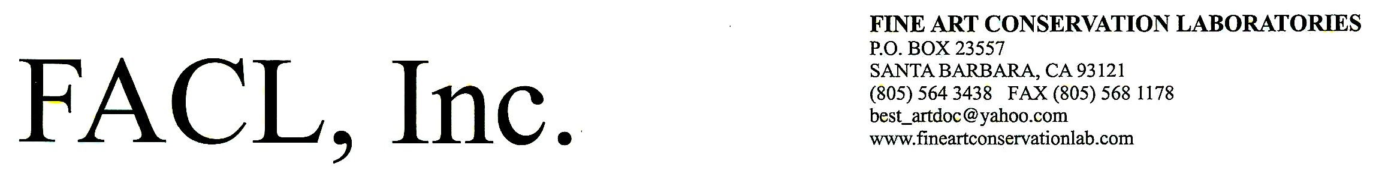

Consultation Services

Consultation services include surveys/assessments, consulting and planning for; murals, art on paper, painting collections and historic properties; setting collection conservation/preservation priorities, long-range planning and short-range budget plans, evaluations of storage facilities and environmental needs, consultant for traveling exhibitions/shipping, emergency preparedness and disaster response planning and research, insurance evaluations connected with emergency/damage surveys, acquisition/deaccession evaluations, grant preparation and applications, fundraising, expert testimony/ legal witness services. We provide these services on a continual basis, sometimes on a quick one-task basis and sometimes as a key player on a team for a long term project. Some of the more notable public/private institutional clients for these services have been:

- Caltrans (California State Highway Dept.) – Los Angeles Freeway Murals (link)
- Mural Conservancy of Los Angeles Graffiti on Los Angeles Freeway Murals (link)
- Haines and Valentino Law Firm (Expert witness), San Francisco, CA - Dahlin vs. Wildside West Bar
- Texas Southern University -TSU Mural Collection (link) Houston, Texas – Collection Survey
- Los Angeles Wholesale Produce Market Monumental Murals (link), Los Angeles, CA
- Homeland Security Outlook (Disaster Prep.), Washington DC
- Small Business Admin Research and Info Clearinghouse (Disaster Prep.)- SBDC Net, S. Antonio, TX
- Thorn Human Resources Information Clearinghouse, (Disaster Prep.), Los Angeles, CA
- City of Los Angeles, Community Redevelopment Agency, Cultural Arts Dept/Fund (Murals)
- The Jonathan Club (Painting Collection), Los Angeles, CA Collection Survey
- Banca d’Italia Development Dept., (Graffiti/street art mural conservation/restoration planning on massive real estate development), Verona, Italy
- Lowry’s Corporation (Painting collection in nine locations), Los Angeles, CA Collection Survey
- Bonhams and Butterfield Auctioneers and Appraisers, Los Angeles, San Francisco, CA (Paintings – Analysis – Damage Response)
- John Moran antique and Fine Art Auctioneers (Paintings – Analysis – Damage Response), Alta Dena, CA
- Japanese American National Museum (Painting Collection), Los Angeles, CA
- National Park Service (Murals), United States Government
- The General Services Administration (Murals, Painting Collection incl Art on Paper), US Government, Washington DC
- Department of Labor Expert Witness(link), United States Government
- Dept. Of Transportation (Murals), United States Government
- Ente Nazionale Per l’Istruzione ACLI, Botticino (BS) (Murals, Painting Collection), Italy
- City of Dallas Monumental Murals (link), Texas
- The Archdiocese of Los Angeles (Murals, Disaster Response)
- The Irvine Museum, Irvine (Orange County), CA, Collection planning – See short video
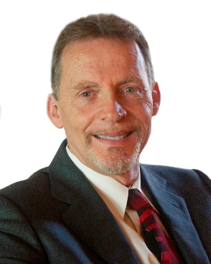
- Los Angeles Central Library (Monumental Murals), City of Los Angeles
- Hardy Holzman Pfeiffer and Assoc. (Murals, Disaster Response), Los Angeles and New York
- The City of Burbank (Murals), Burbank, CA
- Brenda Levin and Associates (Murals, Disaster Response), Los Angeles, CA, New York, NY
- The Los Angeles Athletic Club (Painting Collection), Los Angeles, CA
- The Hollywood Athletic Club (Murals, Disaster Response, Expert Witness), Los Angeles, CA
- Saint Monica's Church (Murals, Disaster Response), Santa Monica, CA
- The Historic Mission Inn Corporation (Painting Collection), Riverside, CA
- International Iberian Institute of Art (Painting Collection), Santa Fe, NM
- Friends of Mexico Foundation (Murals, Analysis), Los Angeles, CA
- El Pueblo de Los Angeles Historical Park (Murals, Analysis), CA
- The State Government of Washington (Murals)
- Getty Conservation Institute Murals, Analysis), Marina Del Rey, CA
- The J. Paul Getty Museum (Paintings, Murals, Analysis), Malibu, CA
- Los Alamitos Historical Park (Murals, Analysis), Long Beach, CA
- Native Sons of the Golden West (Painting Collection), San Francisco, CA Collection Survey
- Santa Barbara Museum of Art (Painting Collection), CA Collection Survey
- University of California at Santa Barbara (Painting Collection), CA Collection Survey
- Friends of the Mission Inn (Painting Collection), Riverside, CA Collection Survey
- Institute of Museum and Library Services, US Government, Washington DC - Consultant and reviewer for Collection Survey grant applications nationwide since 1986.
- Lassen International (Painting Collection), Maui, HI and Las Vegas, NV
- Museum of Art and Church History (Murals, Painting Collection), Salt Lake City, UT
- Bain Investments Int'l (Painting Collection), Los Angeles, New York, London, Tokyo Collection Survey
- Schmidt Estate Collections (Painting Collection), Locarne, Switzerland
- ENAIP Lombardy Regional Conservation Center (Murals, Painting Collection), Botticino, Italy
- Santa Barbara Trust for Historical Preservation (Painting Collection), CA
- Margaret Mallory Collection (Painting Collection), CA Collection Survey
- Leigh B. Block Collection (Painting Collection), CA Collection Survey
- Brigham Young University (Murals, Painting Collection), Provo, UT Collection Survey
- State of Utah Art Collection (Painting Collection), Utah Arts Council, Salt Lake City, UT Collection Survey
- History Dept., Church of Jesus Christ of Latter-day Saints (Murals, Painting Collection), SLC, UT
- Daughters of the Utah Pioneers Museum (Murals, Painting Collection), Salt Lake City, UT
- Springville Museum of Art (Painting Collection), Springville, UT
- The Shroud of Turin Project (Analysis), Getty Conservation Institute, Los Angeles, CA
- Cavriana Archaeological Museum (Analysis), Cavriana, Italy
- Montini Family Collection Pope Paul III (Painting Collection), Lumezzane, Italy
- Museum of Ex-Monastero della Trinitá (Painting Collection), Botticino, Italy

Received October 2, 2003: National Trust for Historic Preservation Award , National Preservation Award which is the highest award for professional preservation from the United States Government for services rendered to the Fair Park, Dallas Texas

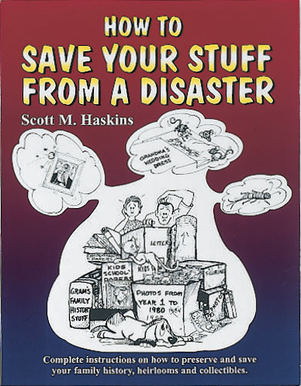
“This information needs to be in the hands of every staff member in every FEMA office in disaster areas.” Dr. Bill Henriques, Public Information Officer, Federal Coordinating Officer for Disasters, FEMA, National Contingency Program, Public Affairs

Scott M. Haskins provides free emergency preparedness and disaster planning content for blogs and newsletters of companies and organizations that distribute information to their members, the public or a constituency. For articles, photos, videos see:
www.preservationcoach.com
http://www.saveyourstuff.com
http://www.fineartconservationlab.com
Ask me how we can leverage our expertise & publications to fundraise for you.

